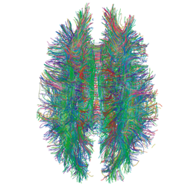
Diagraming History
World History: Patterns of Interaction
Module 1: The Beginnings of World History
Lesson 4: “Neolithic Cultures”
(Page 29)

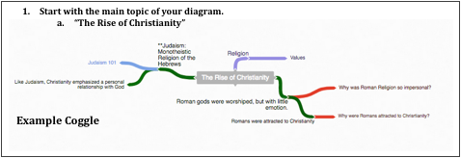

Instructions

Either using a pencil and poster paper or an online diagramming program like Coggle, create an interactive set of notes for this reading. Students will be divided into groups of 2.

Each Member of the group will be responsible for one part of Section 1. Insert these questions, along with answers where it is appropriate in your Coggle. Some of these questions require thought and are not just obvious in the reading.

- Pre-Civilization Cultures
  - What effect did geography have on the development of Jericho?
  - How did the people of Skara Brae make use of the natural resources around them?
- Neolithic Cultures Leave Their Mark
  - Which of the theories presented to explain the purpose of Stonehenge which do you think is most likely to be true?
  - How was society at Stonehenge different from that of most other Neolithic societies?

When your group is finished, each person will present their part of the Coggle and questions that you came up with, will be discussed within your group. Each Group will share out their Coggle to the other groups.
Free Online Diagraming Program Link To Coggle: https://coggle.it/login

Resource: How to use Coggle Video

2. Use the following colors to distinguish different parts of your diagram.

Notes: Instruction: As you read through the information, write notes –diagraming them as you see the relationship to the main topic.

Questions Instruction: Answer the critical thinking questions above. As you read through the information, write questions that may develop in your mind that can be used during discussion.

Concepts Instruction: As you read through the information, try to identify Social Studies Concepts that you feel are related to the information. Each main topic should have a Concept linked to it.

Link To Social Studies Concepts: https://www.historysimulation.com/concept-based-learning.html

Links To Outside Information Instruction: As you develop your diagram, when you come to information or topics you feel need more information or are just curious about- search out a link to add to your diagram. Chances are your readers will also be curious as well. Each Main topic should have a couple outside links within it.

Grading
0-4 Rating

 | Score: 0 |  | Score: 1 |  | Score: 2 |  | Score: 3 |  | Score:4
 | No attempt Made |  | Needs Work |  | Average |  | Very Good |  | Elite

When we finish the Coggle, each group will share their Coggle with another group to be evaluated. Groups will also evaluate their own work as well.

Organization: Notes are organized in a way that allows the viewer to understand relationships to other notes, chronological order or denotes the visual organization of Topics and Subtopics. Information is not in random order.

Concepts: Concepts are located with the Notes they correspond to. Remember: Concepts are broad topics that are adaptable to many topics and not specific.

Questions: are located in relation to the information they correspond with.

Links: Coggle includes links to sites that explain further the topic or subtopics.

