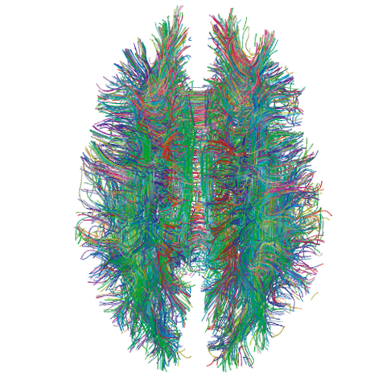
Diagraming History
World History: Patterns of Interaction
Module 13: People and Empires In The Americas
Lesson 6: “The Aztecs Control Central Mexico”
(Page 516)

Instructions

Either using a pencil and poster paper or an online diagraming program like Coggle, create an interactive set of notes for this reading. Students will be divided into groups of 5.

Each Member of the group will be responsible for one part of Lesson 6. Insert these questions, along with answers where it is appropriate in your Coggle. Some of these questions require thought and are not just obvious in the reading.

- The Valley of Mexico (Person 1)
  - Might Teotihuacan have had a defense industry?
  - What might inspire a ruler to try to change a state religion?
- The Aztec Empire (Person 2)
  - Why might stories and myths about origins be important to a nation?
  - What comparisons and contrasts can you make between the Triple Alliance and the Iroquois League?
- Tenochtitlan: A Planned City (Person 3)
  - How did Tenochtitlan’s planners envision the city?
  - What non-food items might vendors have sold Tlatelolco?
- Religion Rules Aztec Life
  - Why was religion such a central feature of Aztec Life?
  - How might ordinary Aztecs have felt about the blood sacrifices to Huitzilopochtli?
- Problems In The Aztec Empire
  - Why might a rapidly growing population such as Tenochtitlan’s be a source be a source of political problems?
  - What drawbacks might Montezuma II have expected by cutting the number of Aztec officials?

When your group is finished, each person will present their part of the Coggle and questions that you came up with, will be discussed within your group. Each Group will share out their Coggle to the other groups.
Free Online Diagraming Program Link To Coggle: https://coggle.it/login

Resource: How to use Coggle Video

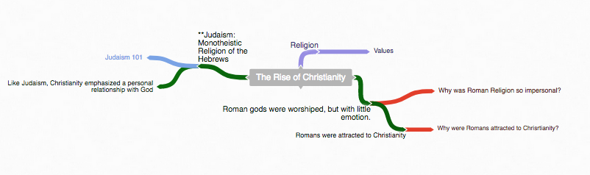
Start with the main topic of your diagram.
“The Rise of Christianity”
Example Coggle

2. Use the following colors to distinguish different parts of your diagram.
Notes
Instruction: As you read through the information, write notes –diagraming them as you see the relationship to the main topic.
Questions
Instruction: Answer the critical thinking questions above. As you read through the information, write questions that may develop in your mind that can be used during discussion.
Concepts
Instruction: As you read through the information, try to identify Social Studies Concepts that you feel are related to the information. Each main topic should have a Concept linked to it.
Link To Social Studies Concepts: https://www.historysimulation.com/concept-based-learning.html
Links To Outside information
Instruction: As you develop your diagram, when you come to information or topics you feel need more information or are just curious about- search out a link to add to your diagram. Chances are your readers will also be curious as well. Each Main topic should have a couple outside links within it.

Grading
0-4 Rating

 | Score: 1 |  | Score: 2 |  | Score: 3 |  | Score: 4
 | Needs Work |  | Average |  | Very Good |  | Elite

When we finish the Coggle, each group will share their Coggle with another group to be evaluated. Groups will also evaluate their own work as well.

Organization: Notes are organized in a way that allows the viewer to understand relationships to other notes, chronological order or denotes the visual organization of Topics and Subtopics. Information is not in random order.

Concepts: Concepts are located with the Notes they correspond to. Remember: Concepts are broad topics that are adaptable to many topics and not specific.

Questions: are located in relation to the information they correspond with.

Links: Coggle includes links to sites that explain further the topic or subtopics.
These materials were prepared by Harms LLC and have neither been developed, reviewed, nor endorsed by Houghton Mifflin Harcourt Publishing Company, publisher of the original WORLD HISTORY: Patterns of Interaction work on which this material is based.

