**Instructions**

Either using a pencil and poster paper or an online diagraming program like Coggle, create an interactive set of notes for this reading. Students will be divided into groups of 4.

Each Member of the group will be responsible for one part of Section 4. Insert these questions, along with answers where it is appropriate in your Coggle. Some of these questions require thought and are not just obvious in the reading.

1. **Israel Becomes A State (Person 1)**
   1. How could the claims to land in Palestine true for Jews, Palestinians and Arabs?
   2. Why might the United Nations have been selected to establish the state of Israel?
2. **Israel and Arab States in Conflict (Person 2)**
   1. What prevented the establishment of the Arab State in 1948?
   2. How did Israel triumph so quickly in the Six Day War?
3. **Efforts at Peace (Person 3)**
   1. Why do you think Sadat’s peace initiative enraged Arabs?
   2. How are Yitzhak Rabin and Anwar Sadat similar?
4. **Peace Slips Away (Person 4)**
   1. Why do you think Sharon’s visit to the Temple mount angered Palestinians?
   2. What do you think are the main obstacles to peace between Israel and the Arab states?

When your group is finished, each person will present their part of the Coggle and questions that you came up with, will be discussed within your group. Each Group will share out their Coggle to the other groups.

**Free Online Diagraming Program Link To Coggle:** <https://coggle.it/login>

**Resource:** [How to use Coggle Video](https://www.youtube.com/watch?v=cD_fOn2WNfU)

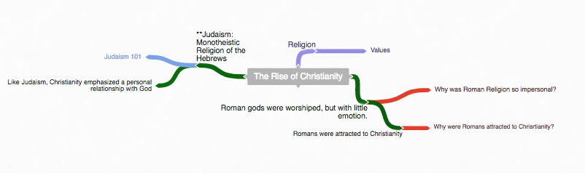

1. **Start with the main topic of your diagram.**
   1. **“The Rise of Christianity”**

**Example Coggle**

**Diagraming History**

World History: Patterns of Interaction

Module 30: The Colonies Become New Nations

Section 4: “Conflicts In The Middle East”

**(Page 1194)**

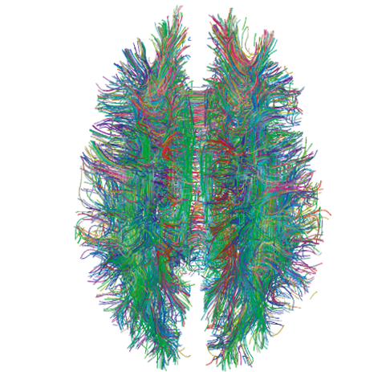

**2. Use the following colors to distinguish different parts of your diagram.**

Notes

**Instruction:** As you read through the information, write notes –diagraming them as you see the relationship to the main topic.

Questions

**Instruction:** Answer the critical thinking questions above. As you read through the information, write questions that may develop in your mind that can be used during discussion.

Concepts

**Instruction:** As you read through the information, try to identify Social Studies Concepts that you feel are related to the information. Each main topic should have a Concept linked to it.

**Link To Social Studies Concepts:** <https://www.historysimulation.com/concept-based-learning.html>

Links To Outside information

**Instruction:** As you develop your diagram, when you come to information or topics you feel need more information or are just curious about- search out a link to add to your diagram. Chances are your readers will also be curious as well. Each Main topic should have a couple outside links within it.

**Grading**

**0-4 Rating**

|  |  |  |  |  |  |  |  |  |  |  |
| --- | --- | --- | --- | --- | --- | --- | --- | --- | --- | --- |
|  |  |  | **Less Than 2** |  | **Score: 2** |  | **Score: 3** |  | **Score: 4** |  |
|  |  |  | Progressing |  | Basic Knowledge |  | Good |  | Elite |  |

When we finish the Coggle, each group will share their Coggle with another group to be evaluated. Groups will also evaluate their own work as well.

**Organization:** Notes are organized in a way that allows the viewer to understand relationships to other notes, chronological order or denotes the visual organization of Topics and Subtopics. Information is not in random order.

**Concepts:** Concepts are located with the Notes they correspond to. Remember: Concepts are broad topics that are adaptable to many topics and not specific.

**Questions:** are located in relation to the information they correspond with.

**Links:** Coggle includes links to sites that explain further the topic or subtopics.

These materials were prepared by Harms LLC and have neither been developed, reviewed, nor endorsed by Houghton Mifflin Harcourt Publishing Company, publisher of the original *WORLD HISTORY*: *Patterns of Interaction* work on which this material is based.