**Instructions**

Either using a pencil and poster paper or an online diagraming program like Coggle, create an interactive set of notes for this reading. Students will be divided into groups of 5.

Each Member of the group will be responsible for one part of Lesson 3. Insert these questions, along with answers where it is appropriate in your Coggle. Some of these questions require thought and are not just obvious in the reading.

1. **Gorbachev Moves Toward Democracy (Person 1)**
   1. Why might youth alone have made Mikhail Gorbachev more willing to pursue new ideas?
   2. Why did it take so long for Soviet leaders to reform their system?
2. **Reforming the Economy and Politica (Person 2)**
   1. Why might Gorbachev have chosen to allow private businesses only on a small scale?
   2. Why might people have voted for powerful party bosses rather than for candidates who advocated change?
3. **The Soviet Union Faces Turmoil (Person 3)**
   1. Based on Gorbachev’s use of force in Lithuania in 1991 what were his views on the future of the Soviet Union at that time?
   2. Why might Soviet military leaders have ignored orders to attack the parliament?
   3. Why might the August Coup have accelerated the break up of the Soviet Union?
4. **Russia under Boris Yeltsin (Person 4)**
   1. What consequences might result from 800% inflation?
   2. How might Yeltsin’s response to Chechnya’s declaration of independence parallel Gorbachev’s Reaction to Lithuania’s?
5. **Russia under Vladimir Putin (Person 5)**
   1. How might Russians have felt about Yeltsin appointing Putin instead of calling for an early election
   2. What do you think will happen to the Russian Republic if the current economic trend continues?

When your group is finished, each person will present their part of the Coggle and questions that you came up with, will be discussed within your group. Each Group will share out their Coggle to the other groups.

**Free Online Diagraming Program Link To Coggle:** <https://coggle.it/login>

**Resource:** [How to use Coggle Video](https://www.youtube.com/watch?v=cD_fOn2WNfU)

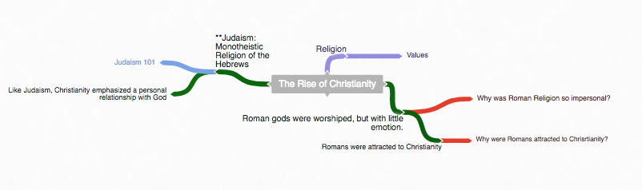

1. **Start with the main topic of your diagram.**
   1. **“The Rise of Christianity”**

**Example Coggle**

**Diagraming History**

World History: Patterns of Interaction

Module 31: Struggles For Democracy

Lesson 3: “The Collapse of the Soviet Union”

**(Page 1235)**

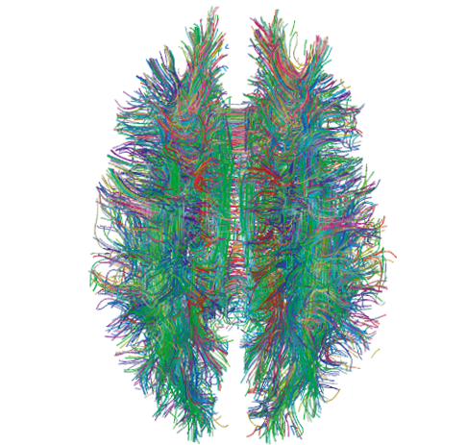

**2. Use the following colors to distinguish different parts of your diagram.**

Notes

**Instruction:** As you read through the information, write notes –diagraming them as you see the relationship to the main topic.

Questions

**Instruction:** Answer the critical thinking questions above. As you read through the information, write questions that may develop in your mind that can be used during discussion.

Concepts

**Instruction:** As you read through the information, try to identify Social Studies Concepts that you feel are related to the information. Each main topic should have a Concept linked to it.

**Link To Social Studies Concepts:** <https://www.historysimulation.com/concept-based-learning.html>

Links To Outside information

**Instruction:** As you develop your diagram, when you come to information or topics you feel need more information or are just curious about- search out a link to add to your diagram. Chances are your readers will also be curious as well. Each Main topic should have a couple outside links within it.

**Grading**

**0-4 Rating**

|  |  |  |  |  |  |  |  |  |  |  |
| --- | --- | --- | --- | --- | --- | --- | --- | --- | --- | --- |
|  |  |  | **Less Than 2** |  | **Score: 2** |  | **Score: 3** |  | **Score: 4** |  |
|  |  |  | Progressing |  | Basic Knowledge |  | Good |  | Elite |  |

When we finish the Coggle, each group will share their Coggle with another group to be evaluated. Groups will also evaluate their own work as well.

**Organization:** Notes are organized in a way that allows the viewer to understand relationships to other notes, chronological order or denotes the visual organization of Topics and Subtopics. Information is not in random order.

**Concepts:** Concepts are located with the Notes they correspond to. Remember: Concepts are broad topics that are adaptable to many topics and not specific.

**Questions:** are located in relation to the information they correspond with.

**Links:** Coggle includes links to sites that explain further the topic or subtopics.

These materials were prepared by Harms LLC and have neither been developed, reviewed, nor endorsed by Houghton Mifflin Harcourt Publishing Company, publisher of the original *WORLD HISTORY*: *Patterns of Interaction* work on which this material is based.