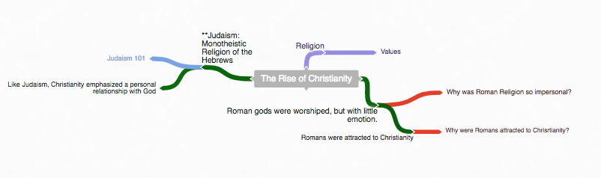
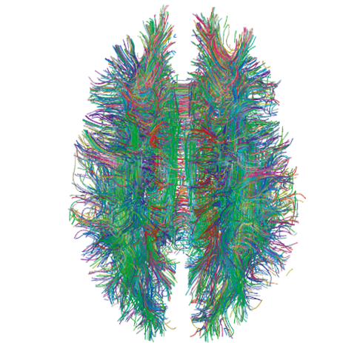
Instructions

Either using a pencil and poster paper or an online diagraming program like Coggle, create an interactive set of notes for this reading. Students will be divided into groups of 5.

Each Member of the group will be responsible for one part of Lesson 5. Insert these questions, along with answers where it is appropriate in your Coggle. Some of these questions require thought and are not just obvious in the reading.

- The Legacy of Mao (Person 1)
  - Do you think Chinese peasants favored a Communist takeover of China?
  - What might Mao have hoped to achieve by replacing family life with communes?
- China and The West (Person 2)
  - Why might have Zhou have chosen to invite a U.S. table tennis team to China?
  - Are Deng’s Four Modernizations consistent with Communism?
- Massacre In Tiananmen Square (Person 3)
  - Why might Deng have been successful in crushing dissent when so many Eastern European leaders had failed?
  - Why are students so often involved in protest movements?
- China Enters The New Millennium (Person 4)
  - Why might U.S. leaders pressure China to improve its human rights record?
  - Why might China have promised to respect Hong Kong’s economic system and political liberties for 50 years?
- China Beyond 2000 (Person 5)
  - What might have happened if China’s leaders had adopted a “Shock Therapy” economic policy?
  - Do you think the best way to prompt political change in China is through greater engagement, not isolation.

When your group is finished, each person will present their part of the Coggle and questions that you came up with, will be discussed within your group. Each Group will share out their Coggle to the other groups.
Free Online Diagraming Program Link To Coggle: https://coggle.it/login

Resource: How to use Coggle Video
- Start with the main topic of your diagram.
  - “The Rise of Christianity”
Example Coggle
Diagraming History
World History: Patterns of Interaction
Module 31: Struggles For Democracy
Section 5: “China: Reform & Reaction”
(Page 1253)

2. Use the following colors to distinguish different parts of your diagram.
Notes
Instruction: As you read through the information, write notes –diagraming them as you see the relationship to the main topic.
Questions
Instruction: Answer the critical thinking questions above. As you read through the information, write questions that may develop in your mind that can be used during discussion.
Concepts
Instruction: As you read through the information, try to identify Social Studies Concepts that you feel are related to the information. Each main topic should have a Concept linked to it.
Link To Social Studies Concepts: https://www.historysimulation.com/concept-based-learning.html
Links To Outside information
Instruction: As you develop your diagram, when you come to information or topics you feel need more information or are just curious about- search out a link to add to your diagram. Chances are your readers will also be curious as well. Each Main topic should have a couple outside links within it.

Grading
0-4 Rating

 |  |  | Less Than 2 |  | Score: 2 |  | Score: 3 |  | Score: 4
 |  |  | Progressing |  | Basic Knowledge |  | Good |  | Elite

When we finish the Coggle, each group will share their Coggle with another group to be evaluated. Groups will also evaluate their own work as well.

Organization: Notes are organized in a way that allows the viewer to understand relationships to other notes, chronological order or denotes the visual organization of Topics and Subtopics. Information is not in random order.

Concepts: Concepts are located with the Notes they correspond to. Remember: Concepts are broad topics that are adaptable to many topics and not specific.

Questions: are located in relation to the information they correspond with.

Links: Coggle includes links to sites that explain further the topic or subtopics.
These materials were prepared by Harms LLC and have neither been developed, reviewed, nor endorsed by Houghton Mifflin Harcourt Publishing Company, publisher of the original WORLD HISTORY: Patterns of Interaction work on which this material is based.

