**Instructions**

Either using a pencil and poster paper or an online diagraming program like Coggle, create an interactive set of notes for this reading. Students will be divided into groups of 5.

Each Member of the group will be responsible for one part of Lesson 4. Insert these questions, along with answers where it is appropriate in your Coggle. Some of these questions require thought and are not just obvious in the reading.

1. **What Is Terrorism? (Person 1)**
   1. How might globalization be a factor in the growth of terrorism?
   2. Why is cyber terrorism such a threat?
2. **Terrorism Around The World (Person 2)**
   1. How would you compare terrorism in the Middle East to terrorism in Northern Ireland?
   2. Why was the attack on the Tokyo subway system significant?
3. **Attack On The United States (Person 3)**
   1. Why were Americans so shocked by the attack of September 11th 2001?
   2. How would you contrast the anthrax attacks with the attack of September 11th?
4. **The United States Responds (Person 4)**
   1. Why did the USA Patriot Act order banks to investigate large foreign accounts?
   2. What was the psychological impact of using sky marshals and national guard troops for aviation security?
5. **Global Effects of Terrorism (Person 5)**
   1. What was the global response to a recent terror attack?
   2. What effects might the threat of global terrorism have on international travel?

When your group is finished, each person will present their part of the Coggle and questions that you came up with, will be discussed within your group. Each Group will share out their Coggle to the other groups.

**Free Online Diagraming Program Link To Coggle:** <https://coggle.it/login>

**Resource:** [How to use Coggle Video](https://www.youtube.com/watch?v=cD_fOn2WNfU)

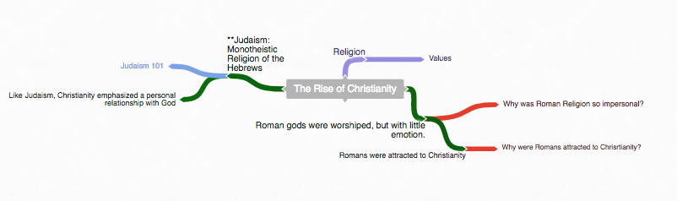

1. **Start with the main topic of your diagram.**
   1. **“The Rise of Christianity”**

**Example Coggle**

**Diagraming History**

World History: Patterns of Interaction

Module 32: Global Interdependence

Lesson 4: “Terrorism”

**(Page 1295)**

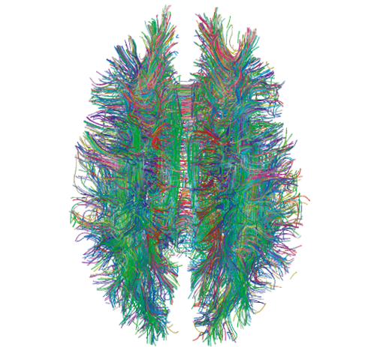

**2. Use the following colors to distinguish different parts of your diagram.**

Notes

**Instruction:** As you read through the information, write notes –diagraming them as you see the relationship to the main topic.

Questions

**Instruction:** Answer the critical thinking questions above. As you read through the information, write questions that may develop in your mind that can be used during discussion.

Concepts

**Instruction:** As you read through the information, try to identify Social Studies Concepts that you feel are related to the information. Each main topic should have a Concept linked to it.

**Link To Social Studies Concepts:** <https://www.historysimulation.com/concept-based-learning.html>

Links To Outside information

**Instruction:** As you develop your diagram, when you come to information or topics you feel need more information or are just curious about- search out a link to add to your diagram. Chances are your readers will also be curious as well. Each Main topic should have a couple outside links within it.

**Grading**

**0-4 Rating**

|  |  |  |  |  |  |  |  |  |  |  |
| --- | --- | --- | --- | --- | --- | --- | --- | --- | --- | --- |
|  |  |  | **Less Than 2** |  | **Score: 2** |  | **Score: 3** |  | **Score: 4** |  |
|  |  |  | Progressing |  | Basic Knowledge |  | Good |  | Elite |  |

When we finish the Coggle, each group will share their Coggle with another group to be evaluated. Groups will also evaluate their own work as well.

**Organization:** Notes are organized in a way that allows the viewer to understand relationships to other notes, chronological order or denotes the visual organization of Topics and Subtopics. Information is not in random order.

**Concepts:** Concepts are located with the Notes they correspond to. Remember: Concepts are broad topics that are adaptable to many topics and not specific.

**Questions:** are located in relation to the information they correspond with.

**Links:** Coggle includes links to sites that explain further the topic or subtopics.

These materials were prepared by Harms LLC and have neither been developed, reviewed, nor endorsed by Houghton Mifflin Harcourt Publishing Company, publisher of the original *WORLD HISTORY*: *Patterns of Interaction* work on which this material is based.